



Digital Technology – Multimedia

Year 10

Task 1

Computer Animation

Task 1

Type: Production

Content: Computer Animation

Outcomes: Outcome 1 – Technology process, Outcome 3 – Skills for computer-based

Total marks: 100 marks

Weighting: 25% of the school mark

# **Computer animation**

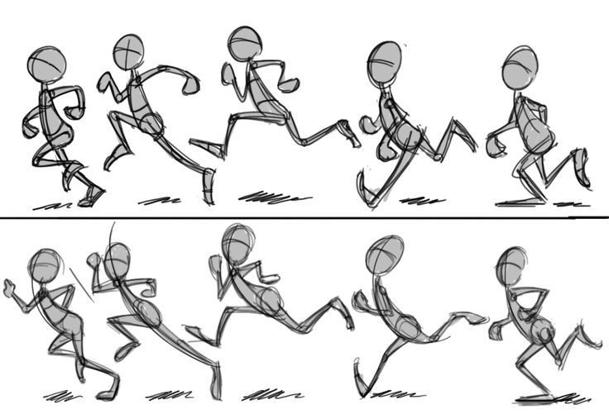

Computer animation is the art of creating moving images via the use of computers.

It is a subfield of computer graphics and animation.

Increasingly it is created by means of 3D computer graphics, though 2D computer graphics are still widely used for low bandwidth and faster real-time rendering needs.

It is also referred to as CGI (Computer-generated imagery or computer-generated imaging), especially when used in films.

To create the illusion of movement, an image is displayed on the computer screen then quickly replaced by a new image that is similar to the previous image but shifted slightly.

This technique is identical to how the illusion of movement is achieved with television and motion pictures.

Computer animation is essentially a digital successor to the art of stop motion animation of 3D models and frame-by-frame animation of 2D illustrations.

**Your task:** In this task, you are to investigate, plan, design and create a computer animation. You will be required to experiment and try different types of animations techniques and software.

The final animation must include your own objects and ideas which you design and model yourself. Final animation must be at least 10 seconds in length and must have a clear narrative.

Be creative!!

**1. Investigate and Define:**

* In this stage you are going to try and experiment with the software and try different techniques. List minimum 3 different techniques of animation and describe them (include samples).

(10 marks)

* Explore the different software by doing the following practice tutorials:
* Animate: Boy animation and Stick-man
* Stop motion
* Photoshop: Stop motion and photo motion

(30 marks)

**Plan and Design:**

* Create a design brief (using the provided template) outlining the animation you intend to create.
* Give detailed descriptions - objects, colours, movement, timing, background, effects, frame rate you will use
* Create a storyboard for your final idea

# Project Proposal

A description of the animation that I want to create:

|  |
| --- |
|  |

(10 Marks)

**Produce:**

* Create your animation in the chosen software using any tools and techniques of your choice.
* Final animation has to be at least 10 seconds in length
* Save and submitted the outputting the animations to video file
* Final animation has to be an original work (not copy and paste tutorials)

(40 marks)

**Evaluate:**

* Develop a survey and collect result from the feedback in the Multimedia class. (6 questions)
* Write an evaluation of your work discussing what features of Blender you used, what were your strengths and weaknesses and what would you liked to have done differently. Consider the feedback collected from the class.

(10 Marks)

**Marking key:**

|  |  |  |
| --- | --- | --- |
| **Component** | **Possible Mark** | **Your Mark** |
| **Investigate and Define**   * Basic description of animation techniques (5 marks) * Detail description of each techniques (10 marks) * Boy animation (5 marks) * Stickman animation (5 marks) * Stop motion animation (10 marks) * Photoshop animations x two (10 marks) | 10  5  5  10  10 |  |
| **Plan and Design**   * Simple descriptions of animation (3 marks) * Discusses animation length and timing with accuracy (5 marks) * Storyboard (5 marks) | 10 |  |
| **Produce**   * Uses original ideas and objects (10 marks) * Creates effective, high quality animation (10 marks) * Creates animations with length required (10 marks) * Creates a clear narrative (10 marks) | 10  10  10  10 |  |
| **Evaluate**   * Basic survey (3 marks) * Well prepare survey with graphical analysis (5 marks) * Basic self-evaluation (3 marks) * Gives detailed discussion of strengths and weaknesses and potential improvements based on feedback (5 marks) | 5  5 |  |

Marks /100